How to Upgrade RAK10701 to RAK10701-Plus
To upgrade the RAK10701, you need to upload the RAK10701-Plus using custom firmware process.
1. Connect your RAK10701 to USB port of your PC/Laptop.
2. Install and open WisToolBox. Click START on Get started page. It will scan the RAK10701. If It shows No device detected, reconnect the RAK10701 and click TRY AGAIN.
Make sure it is detected as COM port. If not, you can try change your USB cable, use different USB port or try on a different machine. You can also charged first the device if it is not used and only stored for a long time.
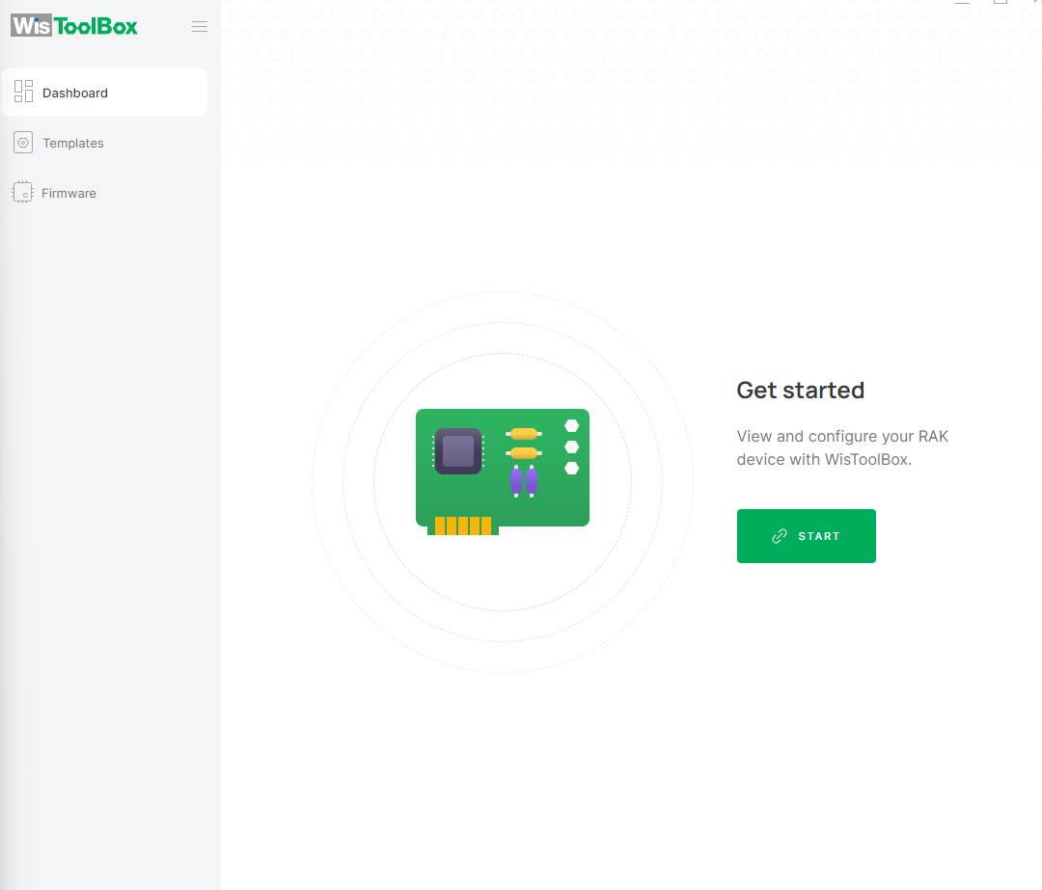
3. You will see CONNECTION SETTINGS if the RAK10701 is detected. It should show the correct device name, it should be RAK10701-L or RAK10701-P. If this is confirmed, you can click CONNECT.
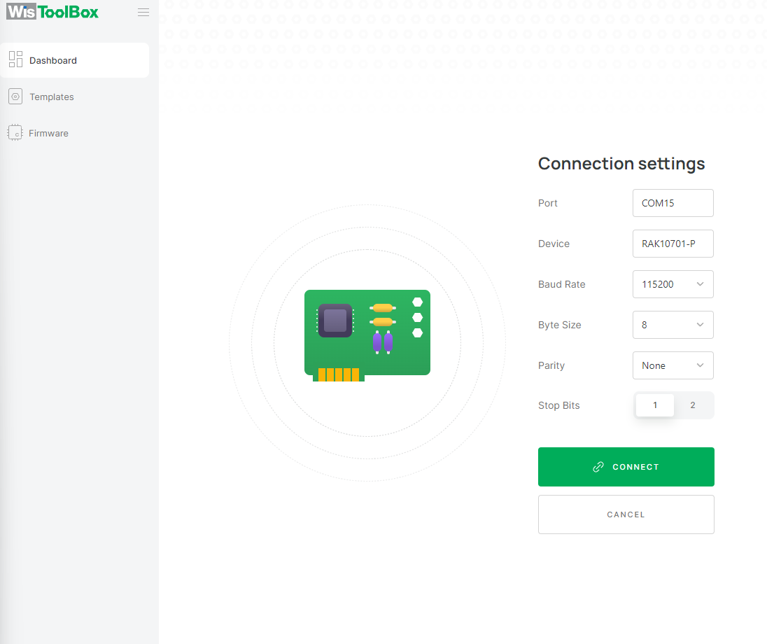
4. Once detected as WisNode Field Tester, click on FIRMWARE. This will bring you to the firmware settings.
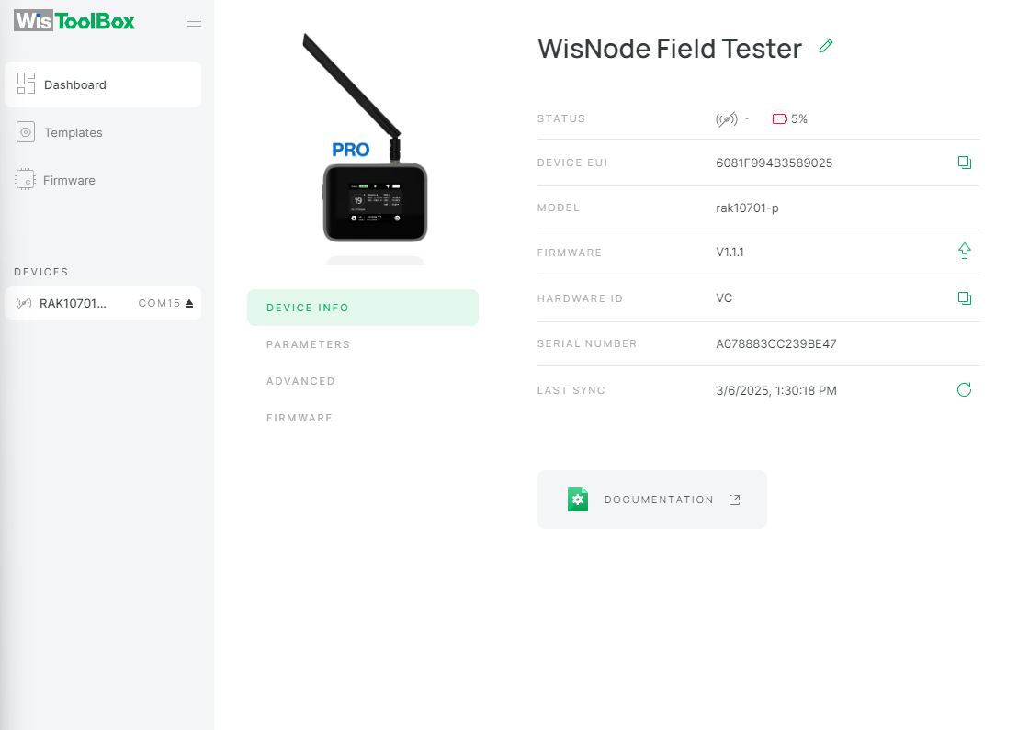
5. On the firmware settings, click Custom. You can drag-and-drop the RAK10701-Plus firmware in this section. You can download the RAK10701-Plus here https://downloads.rakwireless.com/#LoRa/RAK10701-Plus
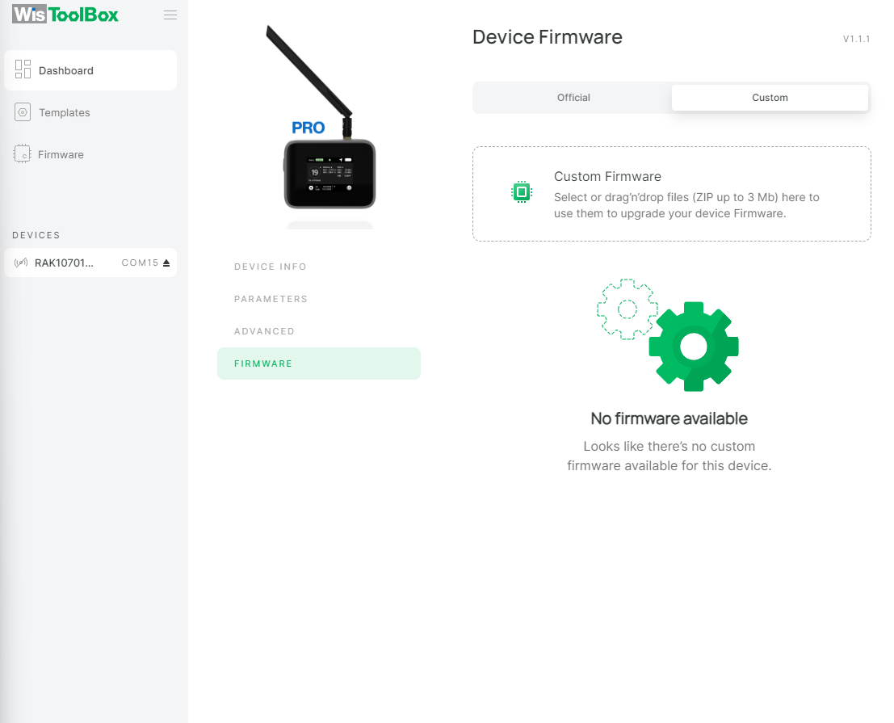
6. After selecting the downloaded Firmware. Click UPGRADE DEVICE then select the UPGRADE button on the pop-up.
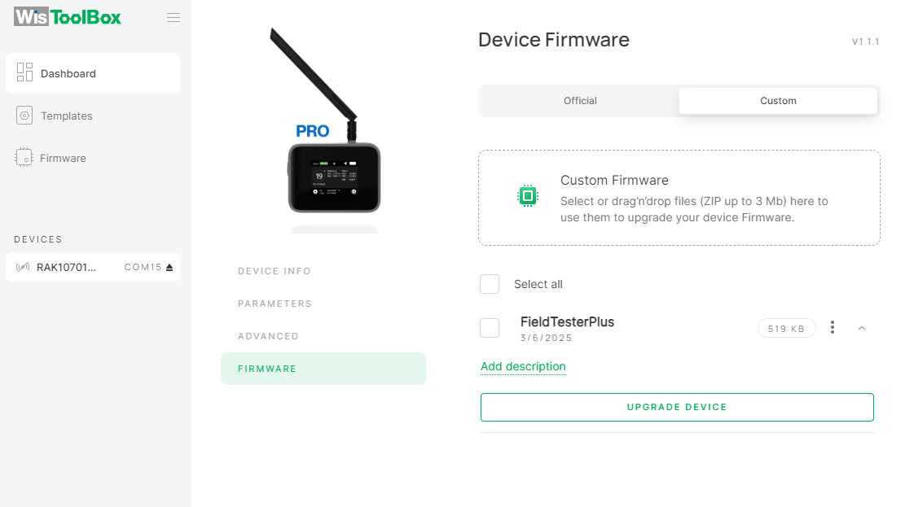
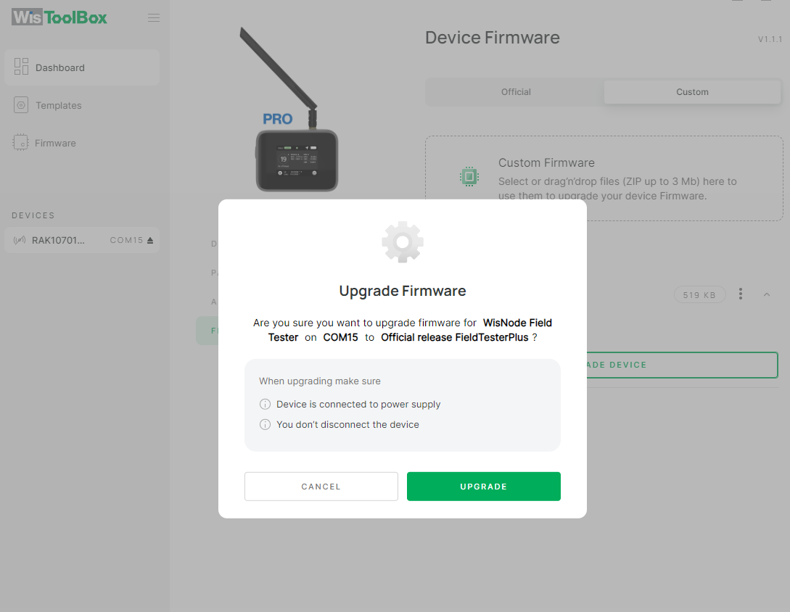
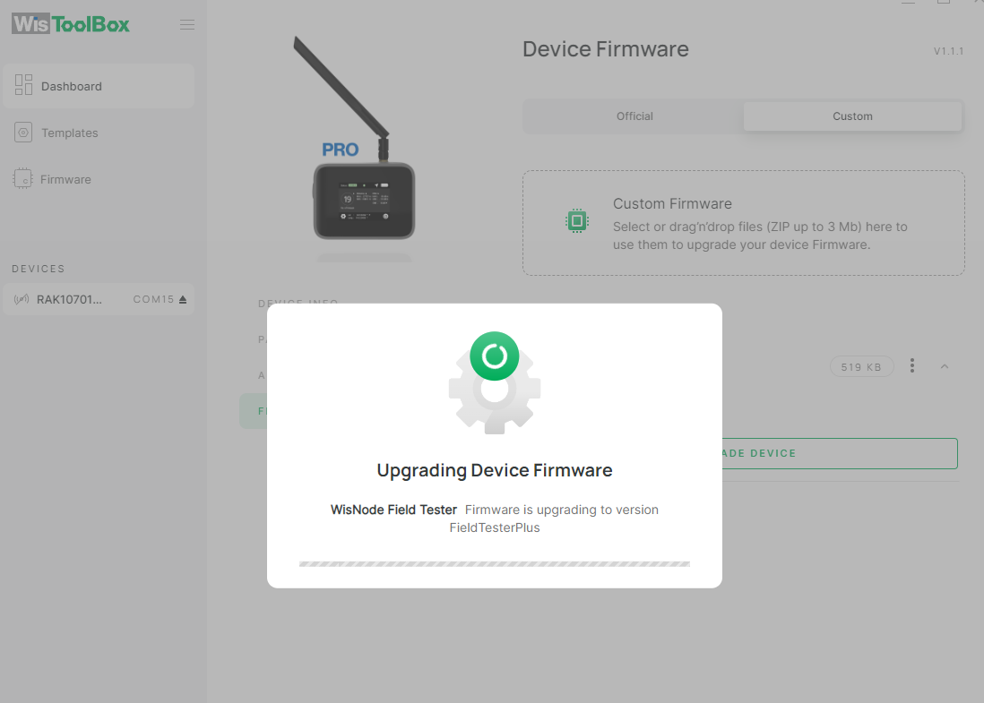
7. Once FW is uploaded. It will now be detected as RAK10701-Plus. You can use the WisToolBox to send the necessary AT commands using the console. WisToolBox V1.4.5 has limited support for RAK10701-Plus.

